**Lab Details**

1. In this lab, we will go through various steps to create azure file shares and how to work with it.
2. Duration: **30 minutes**

**Introduction**

**What is Azure File Share?**

* Azure Storage is the Azure platform's managed service for providing cloud storage. Azure Storage is composed of several core services and supporting features. It is highly available, secure, durable, scalable, and redundant.
* Azure Files offers fully managed file shares in the cloud that are accessible via the industry standard Server Message Block (SMB) protocol or Network File System (NFS).
* Azure file storage mainly can be used if we want to have a shared drive between two servers or across users. In that case, we will go for Azure file storage.
* We can create an unlimited number of file shares within a storage account. Once we create a file share, then we can create directories, just like folders, and then we can upload files into it. Once we create a file share, we can mount that on any virtual machine, whether it is in Azure or outside.
* The SMB protocol is a client-server protocol for accessing shared files, and printers over the network, and for enabling inter-process communication.

**Architecture Diagram**

**Task Details**

1. Sign into the Azure Portal
2. Create a Storage Account
3. Create a File Share
4. Upload a File
5. Connect to the File Share
6. Delete the resources.

# ****Lab Steps****

## ****Task 1: Sign into Azure Portal****

1. Go to the Azure portal by using the URL [https://portal.azure.com](https://portal.azure.com/).
2. Sign in with your given **username** and **password** on the Azure portal.

## ****Task 2: Create a Storage Account****

1. At the top of the Azure portal, in the search box, search **Storage account**. Select **Storage accounts** in the search results.
2. In **Storage accounts**, select **+ Create**.

1. In the **Create a storage account** page, enter or select the following information in the **Basics** tab:

* Resource group: Select **RG1**
* Instance details:
  + Storage account name: Enter a unique name.
  + Region: Select **(US) East US**
  + Performance: Select **Standard**
  + Redundancy: Select **Locally-redundant storage (LRS)**

1. Leave all the settings as default and click on **Review**. Then, click on **Create**. Your deployment will be completed after a few minutes.

## ****Task 3: Create a File Share****

1. Click on **Go to resource**. On the overview page of your storage account, in the **Data storage** section, select **File shares**.

1. Click on **+ File share**.

1. Now, on the **New file share** page, enter or select the following information:

* Name: Enter **myfile123**
* Tier: Select **Hot**
* Click on **Review + create** and then **Create**

1. Your file share will be created and displayed in the file shares section.

## ****Task 4: Upload a File****

1. Now, go to the file share you created. Here, in the overview page of your file share, click on **Upload**.

1. On the **Upload files** page, browse any file on your local computer and select the file. Then, click on **Upload**.

1. You can see the file you have uploaded by clicking the browse option in the left column.

## ****Task 5: Connect to the File Share****

In this task firstly we will create a **Windows Server 2022 Datacenter - Azure Edition - Gen2** VM and then we will check whether the storage account is accessible via TCP port 445, which is the port SMB uses.

1. First, you need to create a virtual machine.
2. In the search box at the top of the Azure portal, enter **Virtual machine**. Select **Virtual machines** from the search results.
3. On the **Virtual machines** tab, select **+ Create > Azure virtual machine**.

1. In the **Create a virtual machine** tab, select or enter the following values in the **Basics** tab.

* Resource group: Select **rg_eastus_XXXXX**
* Instance details:
* Virtual Machine Name: Enter **myWhizlabsVM1**
* Region: Select **(Europe) West Europe**

* Image: Select **Windows Server 2022 Datacenter - Azure Edition - Gen2**
* Size: Click on **See all sizes** then select **B2s** and then click on**Select**

* Administrator Account:
* Username: Enter a username
* Password: Enter a password
* Confirm password: Re-enter password
* Inbound Port rules:
* Public inbound ports: Select **None**

1. Click on the **Next: Disks** button. Select **Standard SSD** for OS Disk type.

Now select the **Monitoring**tab and **Disable** the  “ **Boot diagnostics** ”.

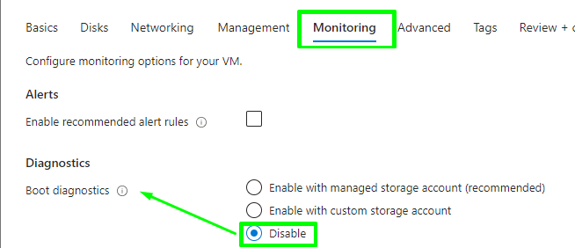

1. Select the **Review + create** button at the bottom of the page and then click on **Create**. After a few minutes, your VM will be deployed.

1. In the search box at the top of the Azure portal page, enter **Virtual machine**. Select **Virtual Machines** in the search results. Select the virtual machine you created “**myWhizlabsVM1**”.

1. On the **Overview** page of your VM, go to the **Networking** section, here you can see the network interface which has the public IP address and the private IP address, and also the inbound and outbound port rules.

1. Click on **Add inbound port rule** and enter or select the following information:

* Source: Select **Service Tag**
* Source service tag: Select **Internet**
* Destination: Select **Any**
* Destination port ranges: Select **3389** for RDP
* Action: **Allow**
* Priority: Enter **100**
* Name: Enter **myport_3389**

1. Click on the **Add** button. Now, the security rule will be created which will ensure that we can connect on port 3389 to the virtual machine.

1. Now, let’s try to connect the virtual machine. Click on the **Connect > RDP**button on the overview page. Then, click on the **Download RDP file** option.

1. Open the downloaded RDP file, you will be asked to enter the **username** and ***password*** for the Remote Desktop Connection.

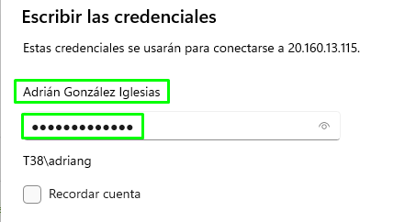

1. Click **OK**. You will now be connected to your Virtual machine.
2. Now, in your virtual machine, open **Windows Powershell** and make sure to **run it as administrator**.

1. Now, On the **overview** page of your file share in the Azure Portal, click on **Connect**.

1. From the **Connect** slideout, click on the **Show Script** button and copy the script, and paste it to a text editor for later use. This script will be used to see if the storage account is accessible via TCP port 445, which is the port SMB uses. If port 445 is available, your Azure file share will be persistently mounted.

1. 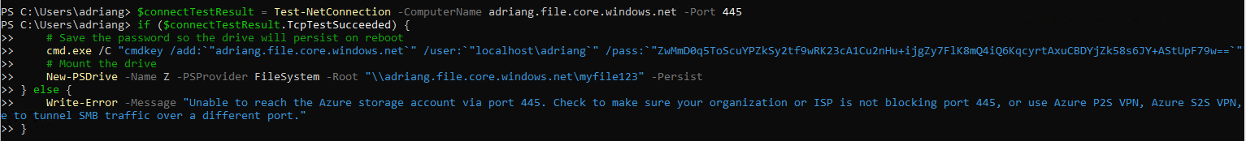Now, paste the above copied script in the **Windows Powershell** which is running in your virtual machine, and hit enter.

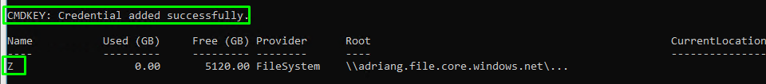

1. Go to the Z drive by running the command “**Z:**” and list the directory contents by running the following command “**dir**”. You will then see your file in your file share.

1. You have now successfully connected to your file share.

### **Do you know?**

Azure File Shares can be accessed not only from Azure VMs but also from on-premises machines and other cloud platforms. You can mount an Azure File Share as a network drive on Windows, Linux, and macOS systems, enabling seamless file sharing and collaboration across different environments.

## ****Task 6: Delete the Resources****

1. In the search box at the top of the Azure portal, enter **Resource groups**. Select **Resource groups** from the search results.
2. Click on the name of one of the **Resource group**.

1. Select all the Resources in that **Resource group.**

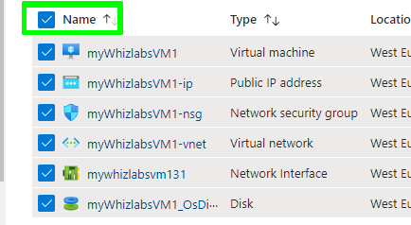

1. Go to three dots to the right and then click the **Delete** button.
2. Now type **delete** in the box present at the bottom.

1. Click on **Delete** to confirm the deletion of resources.

# ****Completion and Conclusions****

1. You have successfully signed into Azure Portal.
2. You have successfully created a Storage Account.
3. You have successfully created a file share.
4. You have successfully uploaded a file.
5. You have successfully connected to the file share.
6. You have successfully deleted the resources.